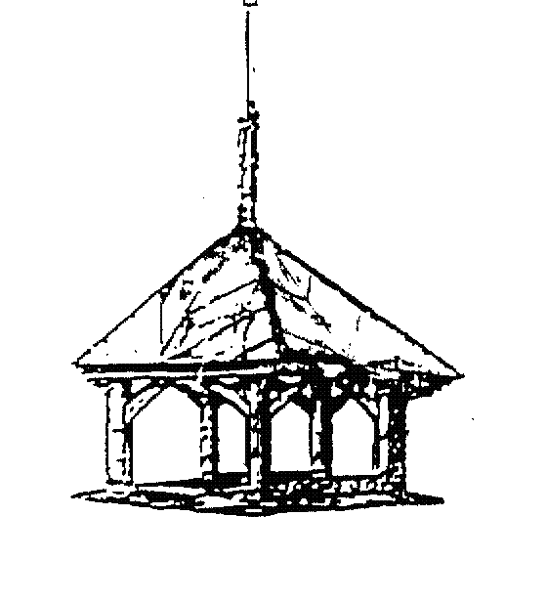
MINUTES OF PATIENT PARTICIPATION GROUP MEETING
Thursday 6th November 2024

ATTENDEES: Sarah-Jane Waites, Dr E Ayers, Frankie Torrance, Greta Thurston, Paul Wood, Jayne Neal, Zoe Morris, Anne Daultrey

ITEM | ACTIONS
Surgery Update  - Industrial Action Update – Dr Ayers explain current action being taken within the surgery to support the industrial action within the NHS.  - Signage – updated names and door signs have been put into place. Additional signage was not cost effective.  - Reception – Recent training given to provide a more personal service.  Communication examples were given by members:  - Staff talking about patients at the front desk, other patients were able to hear.  - Unhelpful staff member at the front desk, patient upset and crying outside.  - Medication Delivery Service  - NHS repeat prescriptions – Not all prescriptions can be ordered.  - Friends of the surgery meeting – 27th November 24, 6pm. | To MA to raise in head of department.  EJA to raise to partners to discuss.  SJW/GT/FT
Patient Education/Services and Information  - Weight loss service – Due to the weight loss service Tier 3 being stopped, Market Cross have enquired about the attendance of the Health and Wellbeing coach. This has been requested through the PCN. Another resource in the surgery being Emma Horn, Social Prescriber who can offer Healthy Wellbeing Services.  - CPR training – PW offering an educational evening, possibly Monday/Tuesdays after 4pm  - Research Team – inviting the new research team to join the PPG meeting. | MA to follow up with James PCN  PW to follow up with availability.  GT/FT to post of Facebook for interest.  SJW/GT
Practice Environment  - Website – now that the website is up and running, to advertise on Facebook.  - Cancellations – Having the option to cancel through email has lowered DNA numbers. Though there is still a high number of DNA's on pre-bookable appointments.  - Telephone Message – The message has been updated, shortened and we have also now added the additional "call-back" feature to hold your place in the queue. Dispensary phones are still to be updated.  - Front Door– not overly welcoming. Window is boarded up, posters, unable to see in creating anxious/unwelcome feeling. Reception to open the blinds to allow light out so that the practice is visibly open and welcoming. | FT  Admin  Reception
Next Meeting:

Thursday 22 January 18:30

