🗓️ Patient Participation Group (PPG) Meeting Minutes
Market Cross Surgery
Date: 21st January 2026
Time: 6.30pm
Location: 7 Market Place, Mildenhall, Suffolk, IP28 7EG
Chair: Sarah-Jane Waites
Note-taker: Greta Thurston

Attendees: John Petty, Freda Petty, Jenny Trett, Simon Trett, Martin Atkins, Barbara Atkins, Jayne Neal

Apologies: Timothy Gillings, Alison Reid, Dawn Banks, Joanne Nichols, Pearl Boreham, Zoe Morris, Anne Daultrey, Christine Davies, Paul Mazey

1. Welcome and Introductions
- Chair’s welcome to all and introductions of our new member Martin Atkins

2. Services and Initiatives

- Introduction of Amba Keeble. Amba explained services covered by her role – She works remotely on Wednesday (telephone appointments) and at Market Cross Surgery on Thursdays face to face.
  - Active Living
  - Wellbeing
  - Financial Advice
  - Loneliness - befriending service https://www.thevoluntarynetwork.org/befriending/ this is also a self-referral service.
This service also provides community transport.
https://www.thevoluntarynetwork.org/community-transport/


- Resource Board
  - Suffolk Family Carers https://suffolkfamilycarers.org/
The Surgery are looking at a new initiative to support
Suffolk Family Carers - i.e Carers Health Check
  - Rural Coffee Caravan - A service run by volunteers to ward
off loneliness – for all ages.
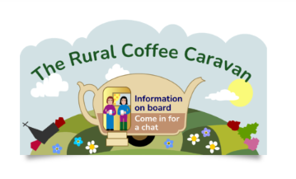

https://ruralcoffeecaravan.org.uk/

- Market Cross Park Run – 7th March 2026
If you would like to be part of the Volunteer take over then please let me know. The run starts at 9am and usually is finished by 11am. We can promote the PPG, along with staff promoting Breast Care and Smears. BP checks will be offered.

- Emma Docherty – Health & Wellbeing
  - Stop smoking
  - Healthy living
  - Wellbeing
  - Support and Coaching
- Dawn Prigg – Cancer Care Nurse
  - Support with new diagnosis
  - Ongoing support

- Physiotherapist
  - Self-referrals can be made through Allied Health
  - In house Physio is available Tuesdays with Ahmed and Wednesdays with Chris – please contact the surgery to request.
  - The surgery no longer do steroid injections but will refer to Newmarket service.

- Minor illness Nurses – Gemma, Maddy, Kelly (supported by Duty Dr.)
- Advanced Nurse Practitioner - Sarah-Jane Waites
- Paramedic – Jim – will do home visits for housebound patients.

Blood test DNA's

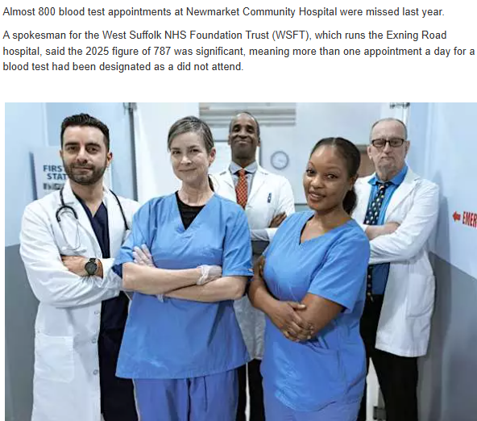

NHS APP https://www.nhs.uk/nhs-app/

What can you access via your NHS app?
- View your test results – if you wish to discuss your results contact the surgery 01638 713109
- View your online medical records – if you cannot currently see this, please contact the surgery to give you access. Please note that not all historical records can be viewed. This will need to be specifically requested; the records will start from the day of your request.
- Order a repeat prescription.

SJW to feedback to surgery – entries written in comments of blood test results are visible to patient. Give clear instructions if there are actions for patients to follow up.

4. Patient Feedback & Suggestions
- Friday 30th Public board meeting – JN to send GT information regarding times and meeting point.
- Councillors meeting – JN to send GT information.
- JN asked about feedback for the CDC diagnostic service – positive feedback from PPG members and staff. Feedback from SJW – RE: Spirometry needing a chest xray, but CDC declining referral for chest xray for this service.
- Phlebotomy – feedback from Market Cross Surgery frustrations with printing blood test forms if patient has lost or forgotten their form.

GT to send out copy of patient survey questions for PPG suggestions.
GT to send copy of Anima help document.

Promoting the use of feedback - https://www.marketcross-surgery.co.uk/

Below is a picture of what the friends and family feedback tool looks like on our website – it is located at the bottom of the home screen.
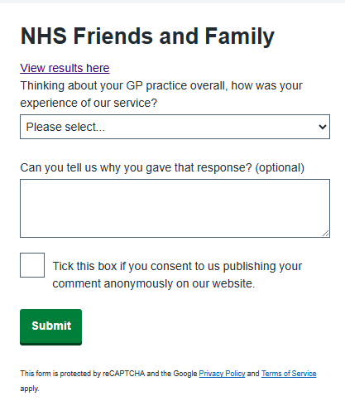

5. Any Other Business (AOB)
JP – asked about Allied Chemist – promoting. We spoke about patients needing to choose their individual choice of chemist/pharmacy collection point.

6. Date of Next Meeting -
Wednesday 22nd April 2026
Wednesday 22nd July 2026
Wednesday 21st October 2026

